

Ref:

Date:
Revision: 1

Fire & Smoke Dampers Typical Detail

Actionair (Swegon)

IP 20-05-17-02 Version 1

Contents

Table of Contents
Overview 1
Actionair SmokeShield – ES Rated Automatic Fire Damper 2
Actionair SmokeShield – DWFX-F (Flange and Cleats) Installation 3
Actionair SmokeShield – DWFX-C (Cleats) Installation 4
Actionair SmokeShield – I/F (Installation Frame) Installation 5
Actionair SmokeShield – Dimensions 6
Actionair SmokeShield – Multiple Installation 7

Overview

This document has been collated to provide typical installation detail for Fire and Smoke Dampers installed in Ventilation Ductwork. A separate document will be provided for Fire Dampers.

COMPANY NAME have chosen to select Actionair (Swegon) as the preferred manufacturer as they have provided the most comprehensive installation and test data. The Fire and Smoke dampers need to be installed in line with one of the test details as noted in the is document.

Please note this document provides a high-level overview of typical installation details. Further details are provided on the actionair website (link below).

SmokeShield – ES Rated Fire Damper

Actionair SmokeShield Fire Damper | www.swegon.com

COMPANY NAME ARE NOT RESPONSIBLE FOR THE FIRE STOPPING DETAIL AROUND THE DAMPER/DUCTWORK. THIS IS THE RESPONSIBILITY OF THE MAIN CONTRACTOR/ARCHITECT TO ENSURE THAT THE COMPARTMENT IS CONSTRUCTED/FIRE STOPPED INLINE WITH THE TESTED DETAIL.

IF THE DAMPER IS NOT INSTALLED INLINE WITH THE TESTED DETAILS, THEN THE INSTALLION WILL NOT BE VALIDATED/SIGNED OFF BUT BUILDING CONTROL WITHOUT 3RD PARTY APPROVAL BY A FIRE ENGINEER.

Please note that there is no tested/approved detail for a fire damper in a white wall (Eurobond or Kingspan); therefore, a fire and smoke damper will need to be provided.

1

Actionair SmokeShield – ES Rated Automatic Fire Damper

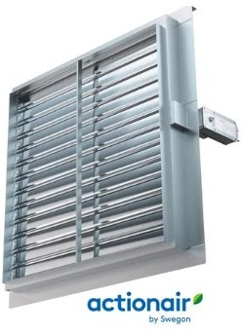

CE Marked fulfilling the requirements of EN 15650

Fire tested to EN 1366-2

Classified to EN 13501-3

Available in both left handed and right handed configurations to suit space requirements

Unique snaplock™ drive interface ensures user friendly connection of actuator to damper

Easy damper connection to square, rectangular, circular and flat oval ductwork

Choice of tested damper installation methods to suit Concrete/Masonry Floors/Walls and Dry Walls

Choice of electrical control modes (actuator)

Unique and patented Electrical Thermal Release (ETR) for ultimate safety

ASFP Grey Book listed

Halogen-free low smoke and fume cabling supplied as standard

Fully compatible with ACTIONPAC Systems

2



EC DECLARATION OF PERFORMANCE

RAM-F-024 G

Smoke Shield PTC V2 HEVAC I/F fire damper Smoke Shield PTC V2 DWFX-F fire damper Smoke Shield PTC V2 DWFX-3F fire damper Smoke Shield PTC V2 DWFX-C fire damper Smoke Shield PTC V2 S&A fire damper Smoke Shield PTC V2 Span fire damper

Complying with the following EU Regulation: 305/2011/EEC : Construction Products Regulation

Swegon Air Management LTD Actionair, South Street, Whitstable, Kent CT5 3DU
System 1
Applus+ – NB0370
Performed the determination of the product type on the basis of type testing and the initial inspection of the manufacturing plant and of factory production control and continuous surveillance, assessment and evaluation of factory control under system 1 and issued the certificate of constancy of conformity of the factory production control (0370-CPR-6281)

Declared performance according to:
BS EN 15650 'Ventilation for buildings: Fire Dampers'

Registered Address
Swegon Air Management Ltd
Stourbridge Rd, Bridgnorth, Shropshire, WV15 5BB, United Kingdom Registered in England No. 738495
+44 (0) 1746 761921
www.swegon.com/uk/ Revision10 15/12/2022



Product | Smoke Shield (SS)
Intended Use | Fire Damper (actuated), to be used in conjunction with fire partitions to maintain compartment integrity in heating  ventilation and air-conditioning (HEVAC) system.
Manufacture | Swegon Air Management Ltd, South Street, Whitstable, Kent CT5 3DU
System of AVCP | System 1
Harmonised Standard/Notified Body/Certificate number | BS EN15650, Applus+, certificate number 0370-CPR-6281
Performance Standard | Testing to BS EN 1366-2, Classification to BS EN 13501-3 EXAP to BS EN 15882-2

Inst. Method | Drawing | Size Range | Supporting Construction | Min Thickness | Min Supporting Construction |  |  | Sensing Element  (See Table Below) | Case Mat. | Blade Mat. | Blade Axis | Performance Classification
DWFX-F | AA/F10704 | 200-1000mm X  200-1000mm | Flexible Wall | 100mm | EI60  Classification | 2x12.5, type F (EN520) board each side | Insulation – at least 30kg/m³ and 40mm thick (insulation optional) | Position A | Galv 430SST  316SST | 430SST  316SST | Horiz | E120(ve i↔o )S - (300Pa)
 |  |  |  |  |  |  |  |  |  |  | Vert | E60(ve i↔o )S - (300Pa) E120(ve i↔o ) - (300Pa)
DWFX-F | AA/F13412 | 200-1000mm X  200-1000mm | Flexible Wall | 75mm | EI30  Classification | 1x12.5, type F (EN520) board each side | Insulation – at least 30kg/m³ and 40mm thick (insulation optional) | Position B | Galv | 430SST | Horiz only | E60(ve i↔o )S - (300Pa)
DWFX-F | AA/F12493 | 200-1000mm X  200-1000mm | Rigid Wall | 100mm | Blockwork |  |  | Position A | Galv 430SST  316SST | 430SST  316SST | Horiz | E120(ve i↔o )S - (300Pa)
 |  |  |  |  |  |  |  |  |  |  | Vert | E60(ve i↔o )S - (300Pa) E120(ve i↔o ) - (300Pa)
DWFX-F | AA/F12493 | 200-1000mm X  200-1000mm | Rigid Wall | 75mm | Blockwork |  |  | Position B | Galv | 430SST | Horiz | E60(ve i↔o )S - (300Pa)
DWFX-F | AA/F13472 | 200-1000mm X  200-1000mm | Flexible Wall | 87mm | Specific wall construction – Shaft Wall GypWall Shaft A306012(A) (EN)  Actuator must be installed on non shaft side to maintain classification |  |  | Position B | Galv | 430SST | Horiz only | E120(ve i↔o )S - (300Pa)
DWFX-F  Muliple | AA/F13409 | 200-2050mm X  200-2075mm | Flexible Wall | 100mm | EI60  Classification | 2x12.5, type F  (EN520) board each side | Insulation – at least  30kg/m³ and 40mm thick (insulation optional) | Position C | Galv | 430SST | Horiz only | E90(ve i↔o )S - (300Pa) E120(ve i↔o ) - (300Pa)
DWFX-F  Muliple | AA/F13410 | 200-2050mm X  200-2075mm | Rigid Wall | 100mm | Blockwork |  |  | Position C | Galv | 430SST | Horiz only | E90(ve i↔o )S - (300Pa) E120(ve i↔o ) - (300Pa)
S/A with BATT | AA/F10710 | 200-1000mm X  200-1000mm | Flexible Wall | 100mm | EI60  Classification | 2x12.5, type F (EN520) board each side | Insulation – at least 30kg/m³ and 40mm thick (insulation optional) | Position A | Galv 430SST  316SST | 430SST  316SST | Horiz | E120(ve i↔o )S - (300Pa)
 |  |  |  |  |  |  |  |  |  |  | Vert | E60(ve i↔o )S - (300Pa) E120(ve i↔o ) - (300Pa)
Registered Address
Swegon Air Management Ltd
Stourbridge Rd, Bridgnorth, Shropshire, WV15 5BB, United Kingdom Registered in England No. 738495
+44 (0) 1746 761921
www.swegon.com/uk/ Revision10 15/12/2022

S/A with BATT | AA/F10712 | 200-1000mm X  200-1000mm | Rigid Wall | 100mm | Blockwork |  |  | Position A | Galv 430SST  316SST | 430SST  316SST | Horiz | E120(ve i↔o )S - (300Pa)
 |  |  |  |  |  |  |  |  |  |  | Vert | E60(ve i↔o )S - (300Pa) E120(ve i↔o ) - (300Pa)
DWFX-F | AA/F13396 | 200-1000mm X  200-1000mm | Composite Wall | 100mm | Specific wall construction – Eurobond Firemaster Wall Extra |  |  | Position A | Galv 430SST  316SST | 430SST  316SST | Horiz | E90(ve i↔o )S - (300Pa)
 |  |  |  |  |  |  |  |  |  |  | Vert | E60(ve i↔o )S - (300Pa) E90(ve i↔o ) - (300Pa)
DWFX-F  Multiple | AA/F13397 | 200 - 2050 X  200 - 2075 | Composite Wall | 100mm | Specific wall construction – Eurobond Firemaster Wall Extra |  |  | Position A | Galv 430SST  316SST | 430SST  316SST | Horiz Only | E90(ve i↔o ) - (300Pa)
DWFX-3F | AA/F11945 | 200-1000mm X  200-1000mm | Flexible Wall | 100mm | EI60  Classification | 2x12.5, type F (EN520) board each side | Insulation – at least 30kg/m³ and 40mm thick (insulation optional) | Position A | Galv 430SST  316SST | 430SST  316SST | Horiz | E120(ve i↔o )S - (300Pa)
 |  |  |  |  |  |  |  |  |  |  | Vert | E60(ve i↔o )S - (300Pa) E120(ve i↔o ) - (300Pa)
DWFX-3F | AA/F12394 | 200-1000mm X  200-1000mm | Rigid Wall | 100mm | Blockwork |  |  | Position A | Galv 430SST  316SST | 430SST  316SST | Horiz | E120(ve i↔o )S - (300Pa)
 |  |  |  |  |  |  |  |  |  |  | Vert | E60(ve i↔o )S - (300Pa) E120(ve i↔o ) - (300Pa)
HEVAC  I/F Frame | AA/F10702 | 200-1000mm X  200-1000mm | Rigid Wall | 150mm | Blockwork density 500kg/m³ |  |  | Position A | Galv 430SST  316SST | 430SST  316SST | Horiz | E120(ve i↔o )S - (300Pa)
 |  |  |  |  |  |  |  |  |  |  | Vert | E60(ve i↔o )S - (300Pa) E120(ve i↔o ) - (300Pa)
DWFX-C | AA/F10708 | 200-1000mm X  200-1000mm | Flexible Wall | 100mm | EI60  Classification | 2x12.5, type F (EN520) board each side | Insulation – at least 30kg/m³ and 40mm thick (insulation optional) | Position A | Galv 430SST  316SST | 430SST  316SST | Horiz | E120(ve i↔o )S - (300Pa)
 |  |  |  |  |  |  |  |  |  |  | Vert | E60(ve i↔o )S - (300Pa) E120(ve i↔o ) - (300Pa)
DWFX-  C slab | AA/F10730 | 200-1000mm X  200-1000mm | Flexible Wall | 100mm | EI60  Classification | 2x12.5, type F (EN520) board each side | Insulation – at least 30kg/m³ and 40mm thick (insulation optional) | Position A | Galv 430SST  316SST | 430SST  316SST | Horiz | E120(ve i↔o )S - (300Pa)
 |  |  |  |  |  |  |  |  |  |  | Vert | E60(ve i↔o )S - (300Pa) E120(ve i↔o ) - (300Pa)
Span | AA/F12368 AA/F12864 | 200-1000mm X  200-1000mm | Slab with Mortar | 150mm | Aerated Concrete density 580kg/m³ |  |  | Position A | Galv 430SST  316SST | 430SST  316SST | N/A | E120(ho i↔o )S - (300Pa)

Sensing Element (Thermal Release) Position | Description
Position A | Can be mounted on either the top, bottom or side of the ductwork, in any position
Position B | Can be mounted on the side of the ductwork, on the centre line or higher
Position C | Can be mounted on the side of the ductwork, 200mm above centre line or higher

Registered Address
Swegon Air Management Ltd
Stourbridge Rd, Bridgnorth, Shropshire, WV15 5BB, United Kingdom Registered in England No. 738495

+44 (0) 1746 761921
www.swegon.com/uk/ Revision10 15/12/2022

Actuator Options | Description
Mode 5 | 24 Volt, Fail Safe Closed
Mode 6 | 230 Volt, Fail Safe Closed
Mode 5-3P | 24 Volt, Modulating, Fail Safe Closed

Essential Characteristic | Performance
Nominal activation conditions/sensitivity according to ISO 10294-4, Sensing element – Response behavior and faulty set-off | Pass
Response delay (response time) according to BS EN 1366-2, Closure time | Pass
Operational reliability according to BS EN 1366-2, Cycling | Pass
Durability of response delay accordingly to BS EN 1366-2, Sensing element response to temperature and load bearing capacity | Pass
Durability of operational reliability according to BS EN 15650, Open and closing cycle | 10,000 cycles nominal Voltage,100 cycles -10% voltage, 100 cycles +15% Voltage
Durability of operational reliability according to BS EN 15650, Open, close and modulating cycle | 10,000 cycles 0º- 90º nominal voltage, 10,000 cycles 45º- 60º nominal voltage
Protection against corrosion according to EN 60068-2-52 | Pass
Damper casing leakage according to BS EN 1751 | Class C
Damper blade leakage according to BS EN 1751(Based on a 1000x1000) | Class 3

This document is assumed to be uncontrolled at the point of printing or saving. Please check the website for the latest version of this document.


Signed for on behalf on the manufacturer

Business Unit Director for Smoke and Fire Solutions Andrew Collard

Registered Address
Swegon Air Management Ltd
Stourbridge Rd, Bridgnorth, Shropshire, WV15 5BB, United Kingdom Registered in England No. 738495

+44 (0) 1746 761921
www.swegon.com/uk/ Revision10 15/12/2022

Actionair SmokeShield – DWFX-F (Flange and Cleats) Installation

3

Actionair DWFX-F Installation Guide
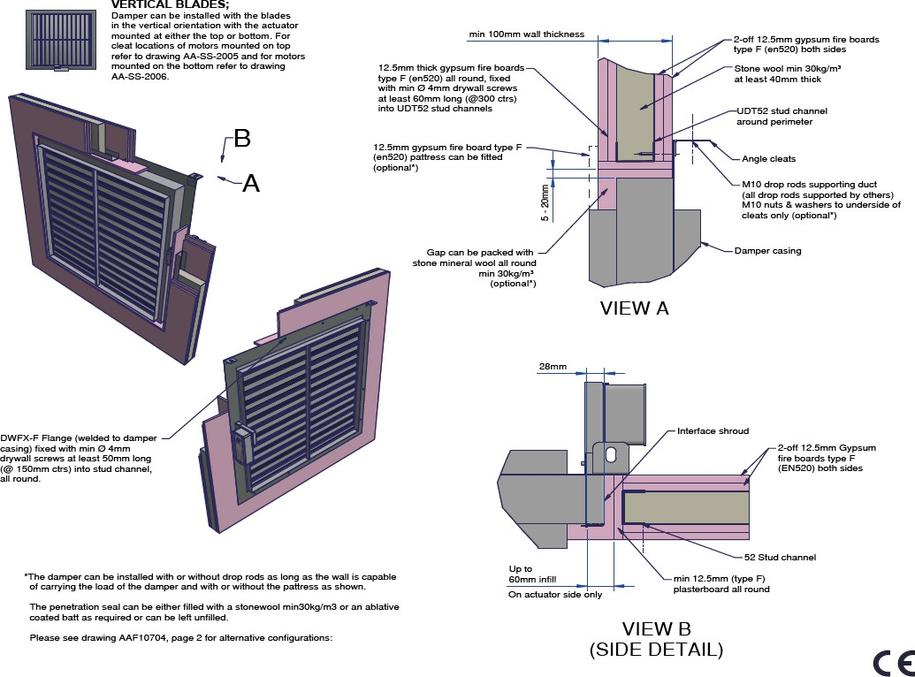

Vertical Damper Installation in a Plasterboard Wall
Actionair SmokeShield PTC - [AA/F13412] 1xType F board each side. [AA/F10704] 2xType F boards each side.

Actionair FireShield -
[AA/F13440] 1xType F board each side. [AA/F10705] 2xType F boards each side.

Installation Method
- Measure the overall Fire damper casing size w x h, but for Smoke Shield include the PTC Shroud
(28mm) in the width but do not include any of the peripheral flange.
- Calculate the hole size using hole sizer program available on www.swegon.com/uk
- For FireShield (AA/F13440) calculate the finished hole size by adding 30mm to the case width and height.
  - For FireShield (AA/F10705) calculate the finished hole size by adding 10-40mm to the case width and height.
- For SmokeShield (AA/F13412) calculate the finished hole size adding 30mm to the case width and height.
  - For SmokeShield calculate the finished
hole size adding 10-52mm to the width and 10-40mm to the height.
- Calculate the hole to cut size by adding two board thicknesses to the finished hole width and height.
- Mark out the hole on the partition and cut it out, cutting the top and bottom edges first to maintain stability.
- Frame out the hole with stud and track and cover this with board. Finish edges with joint filler.
- Drill clearance holes in the damper flange at 150mm centres and such that they will allow screws to pull into the stud and track around the hole.
- Install the damper and fasten.
- Back fill and complete penetration seal as per the installation drawing
- Connecting ductwork omitted for clarity. Ductwork must be independently supported. There must be an appropriate break-away joint between the damper and connecting ductwork on both sides of assembly. Aluminium rivets or plastic cleats, clips, clamps and bolts etc. should be used for this, unless fire resisting ductwork is being
used where fire resisting fixings should be used. A minimum of 200 mm between fire dampers installed in separate ducts and 75 mm between fire damper and a construction element (wall/ floor).

3

20220627 - LNNN00354 (4.2) Swegon reserves the right to alter specifications.

Actionair DWFX-F Installation Guide
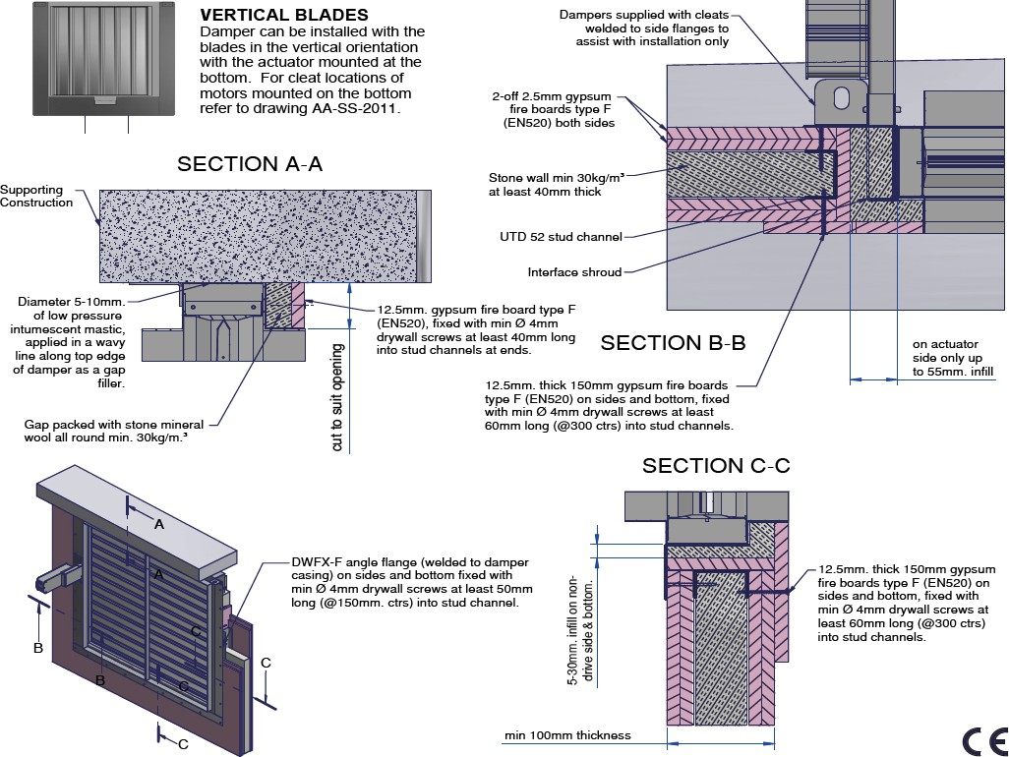

Vertical Damper Installation (Top Flange removed) in a Plasterboard Wall under Concrete Slab
Actionair SmokeShield PTC - [AA/F11945] Actionair FireShield - [AA/F 11944]

Installation Method
- Measure the overall Fire damper casing size w x h, but for Smoke Shield include the PTC Shroud
(28mm) in the width but do not include any of the peripheral flange.
- Calculate the hole size using hole sizer program available on www.swegon.com/uk
- For Fire Shield calculate the finished hole size by adding 10-60mm to the case width and 5-30mm for the height as the head of the damper will be against the slab.
- For Smoke Shield calculate the finished hole size adding 10-57mm to the width and 10-30mm to the height as the head of the damper will be against the slab.
- Calculate the hole to cut size by adding two board thicknesses to the finished hole width and only one for the height.
- Mark out the hole on the partition and cut it out.
- Frame out the hole sides and bottom with stud and track and cover this with board. Finish edges with joint filler.
- Drill clearance holes in the three damper flange sides at 150mm centres and such that they will allow screws to pull into the stud and track around the hole.
- Apply a bead of low pressure intumescent mastic along top edge of damper as a gap filler and Install the damper and fasten.
- Back fill with mineral/stone wool and pattress over this down to the spigot. Fasten with drywall screws at 300mm centres on the sides and bottom such that they will allow screws to pull into the stud and track around the hole. Fix the top pattress into the track at the sides.
- Connecting ductwork omitted for clarity. Ductwork must be independently supported. There must be an appropriate break-away joint between the damper and connecting ductwork on both sides of assembly. Aluminium rivets or plastic cleats, clips, clamps and bolts etc. should be used for this, unless fire resisting duct-work is being used where fire resisting fixings should be used. A minimum separation of 200 mm between fire dampers installed in separate ducts and 75mm between fire damper and a construction element (ie wall/floor) unless otherwise tested.

4 Swegon reserves the right to alter specifications. 20220627 - LNNN00354 (4.2)

Actionair DWFX-F Installation Guide
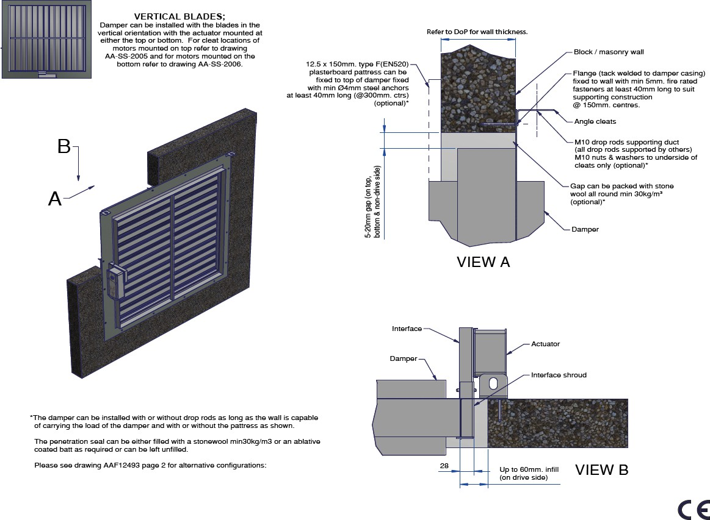

Vertical Damper Installation in a Masonry Wall
Actionair SmokeShield PTC - [AA/F12493] Actionair FireShield - [AA/F10707]

Installation Method
- Drill clearance holes in the damper flange at 150mm centres.
- Install the damper and fix through flange using fire rated fasteners, min ø4mm.
- Back fill and complete penetration seal as per the installation drawing
- Connecting ductwork omitted for clarity. Ductwork must be independently supported. There must be an appropriate break-away joint between the damper and connecting ductwork on both sides of assembly. Aluminium rivets or plastic cleats, clips, clamps and bolts etc. should be used for this, unless fire resisting duct-work is being used where fire resisting fixings should be used. A minimum of 200 mm between
fire dampers installed in separate ducts and 75 mm between fire damper and a construction element (wall/floor).

5
20220627 - LNNN00354 (4.2) Swegon reserves the right to alter specifications.

Actionair DWFX-F Installation Guide

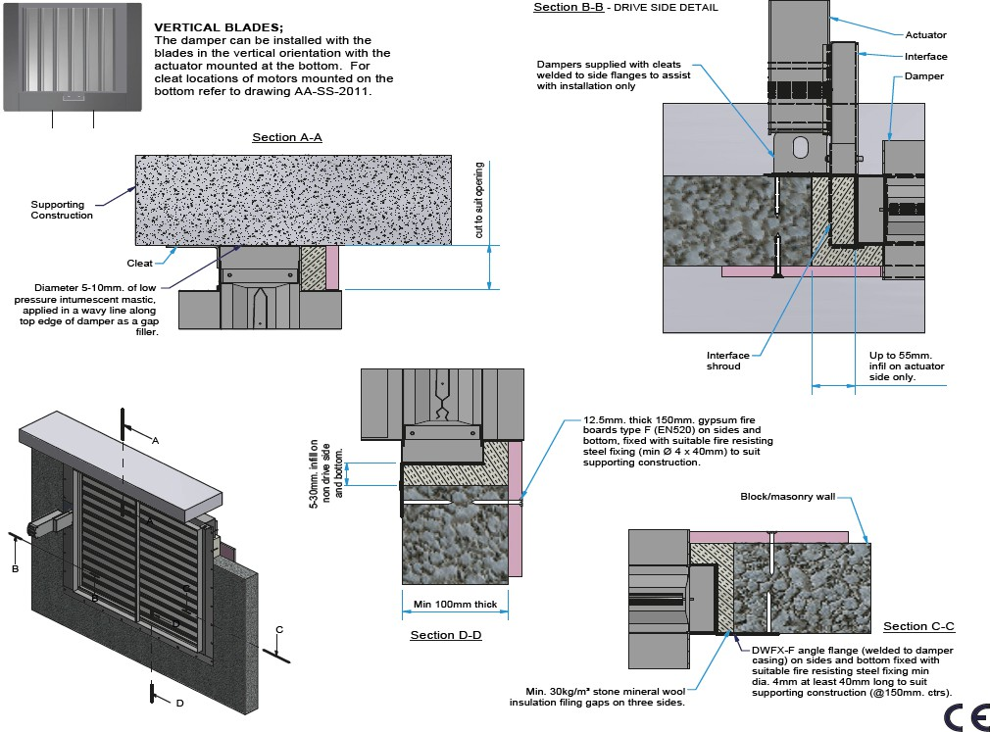

Vertical Damper Installation (Top Flange Removed) In A Masonry Wall Under Concrete Slab
Actionair SmokeShield - [AA/F12394] Actionair FireShield - [AA/F12827]

Installation Method
- Measure the overall Fire damper casing size width x height, but for Smoke Shield include the PTC
Shroud (28mm) in the width but do not include any of the peripheral flange.
- Calculate hole size...
- For Fire Shield calculate the finished hole size by adding 10-80mm to the case width and 5-40mm for the height as the head of the damper will be against the slab.
- For Smoke Shield calculate the finished hole size adding 10-57mm to the width and 5-30mm to the height as the head of the damper will be against the slab.
- Drill clearance holes in the three damper flange's side and bottom at 150mm centres.
- Apply a bead of low pressure intumescent mastic along top edge of damper as a gap filler and install the damper and fasten through flange using fire rated fasteners, min ø4mm.

- Dampers are supplied with cleats and only need to be used to help/assist with the installation before fastening the flange to the wall.
- Back fill with mineral/stone wool and to retain this use a 150mm pattress down to the damper spigot/ duct line. Fasten with fire rated fasteners, min ø4mm at 300mm centres on the sides and bottom. Measure the gap for the top pattress and fix this pattress to the wall either side of the damper, (do not fix at 300ctr to the damper case).
- Connecting ductwork omitted for clarity. Ductwork must be independently supported. There must be an appropriate break-away joint between the damper and connecting ductwork on both sides of assembly. Aluminium rivets or plastic cleats, clips, clamps and bolts etc. should be used for this, unless fire resisting duct-work is being used where fire resisting fixings should be used. A minimum of 200 mm between
fire dampers installed in separate ducts and 75 mm between fire damper and a construction element (wall/floor).

6 Swegon reserves the right to alter specifications. 20220627 - LNNN00354 (4.2)

Actionair DWFX-F Installation Guide

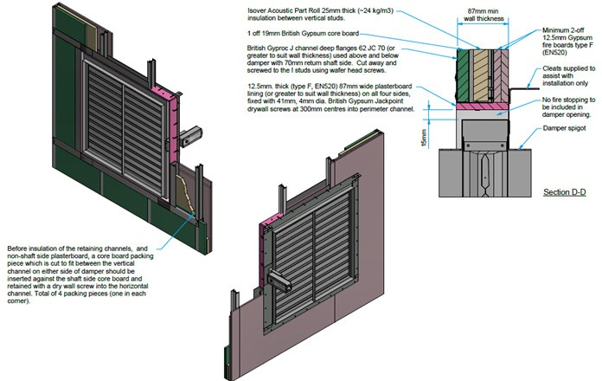

Vertical Damper Installation in a Plasterboard Shaftwall System
Actionair SmokeShield PTC - [AA/F13472]

Installation Method
- Measure the overall Fire damper casing size w x h, including the PTC Shroud (28mm) in the width but do not include any of the peripheral flange.
- Calculate the finished hole size by adding 30mm to the damper width and height.
- Calculate the opening size required (frame to frame) by adding two board thicknesses to the finished hole width and height.
- Create the sub-frame in accordance with the installation drawing, ensuring that the damper aperture is formed to the size obtained from steps 1-3 and using the appropriate Gyproc J Channel to suit the thickness of the wall system being utilised (Refer to Installation Drawing - Details E, F & H).
- Fit the 19mm core board to suit the wall system and secure in position using the appropriate retaining channel following the wall manufacturers standard practice (friction fit). N.B. Before insulation of the retaining channels, and non-shaft side plasterboard, a core board packing piece which is cut to fit between the vertical channel on either side of damper should be inserted against
the shaft side core board and retained with a dry wall screw into the horizontal channel. Total of 4 packing pieces (one in each corner).
- Apply the plasterboard covering to the non-shaft side ensuring any joints are offset (min. 2 x 12.5mm).
- Finish the aperture as detailed with a plasterboard lining. Finish edges with joint filler.
- Drill clearance holes in the damper flange at 150mm centres and such that they will allow screws to pull into the stud and track around the hole.
- Install the damper and fasten ensuring the actuator and peripheral flange are non shaft side to maintain classification.
- Connecting ductwork omitted for clarity. Ductwork must be independently supported. There must be an appropriate break-away joint between the damper and connecting ductwork on both sides of assembly. Aluminium rivets or plastic cleats, clips, clamps and bolts etc. should be used for this, unless fire resisting ductwork is being
used where fire resisting fixings should be used. A minimum of 200 mm between fire dampers installed in separate ducts and 75 mm between fire damper and a construction element (wall/ floor).

7
20220627 - LNNN00354 (4.2) Swegon reserves the right to alter specifications.

Actionair DWFX-F Installation Guide

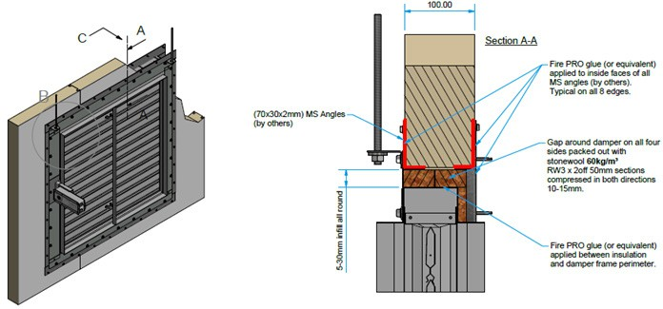

Vertical Damper Installation in a Composite Panel Wall System
Actionair SmokeShield PTC - [AA/F13396]

Installation Method
- Measure the overall Fire damper casing size w x h, including the PTC Shroud (28mm) in the width but do not include any of the peripheral flange.
- Calculate the finished hole size adding 10-60mm to the width and to the height.
- Mark out the hole on the partition and cut it out.
- Frame out the hole with 70x30x2mm mild steel angles (by others) on both sides of the wall and fix at 150mm centres with Fire Pro glue (or equivalent) applied to inside faces of all angles.
- Drill clearance holes in the damper flange at 150mm centres, position the damper and fix to the MS angle with Stainless steel self-drilling composite panel fasteners (min. FIX FAST DF3-SS-HT-A15-5.5x130). Positioned so as to go through damper flange, wall panel and secure into rear metal face of wall panel.

- Back fill and complete penetration seal as per the installation drawing
- Connecting ductwork omitted for clarity. Ductwork must be independently supported. There must be an appropriate break-away joint between the damper and connecting ductwork on both sides of assembly. Aluminium rivets or plastic cleats, clips, clamps and bolts etc. should be used for this, unless fire resisting ductwork is being
used where fire resisting fixings should be used. A minimum of 200 mm between fire dampers installed in separate ducts and 75 mm between fire damper and a construction element (wall/ floor).

8 Swegon reserves the right to alter specifications. 20220627 - LNNN00354 (4.2)

Actionair SmokeShield – DWFX-C (Cleats) Installation



4

Actionair DWFX-C Installation Guide

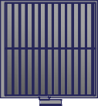
VERTICAL BLADES;
Damper can be installed with the blades in the vertical orientation with the actuator mounted at either the top or bottom refer to drawings for cleat locations;
DWFX-C actuator at top = AA-SS-2000 DWFX-C actuator at bottom = AA-SS-2001
12.5mm thick both sides gypsum fire boards type F (EN520) all round, fixed with min Ø 4mm drywall screws at least 60mm long
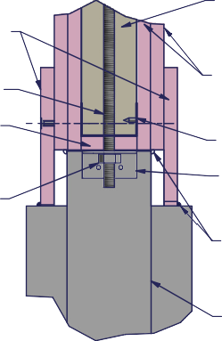
(@300mm centres) into UDT52 stud channels

M10 drop rods.

12.5mm gypsum
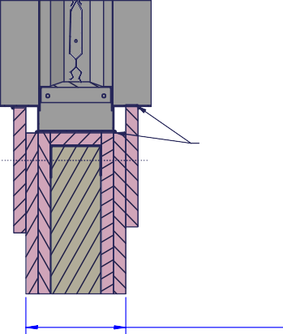
fire board type F (EN520)

M10 nuts

Stone wool min 30kg/m³ min 40mm thick

2-off 12.5mm gypsum fire boards type F (EN520) both sides.

52mm stud channel

Angle cleats welded to damper casing, both ends.

SECTION D-D

Low pressure intumescent mastic, applied all round
& both sides.

VIEW A

Low pressure intumescent mastic, applied all round and both sides.

Damper casing

12.5mm thick gypsum fire boards type F (EN520) to line all round, fixed with min Ø 4mm drywall screws at least 60mm long (@300mm centres) into UDT52 stud channels

UDT52 stud channel

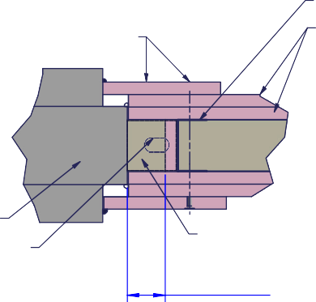
2-off 12.5mm gypsum fire boards type F (EN520) both sides.

min 100mm wall thickness

VIEW B

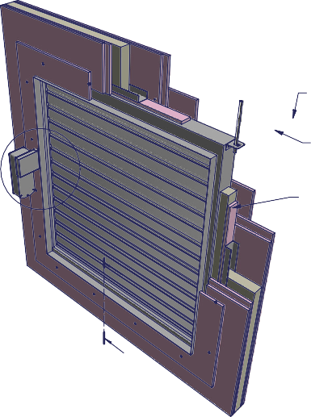
B A
12.5mm gypsum fire board
C
type F (EN520)

D

D
Damper

Angle cleats (shown dotted for clarity).

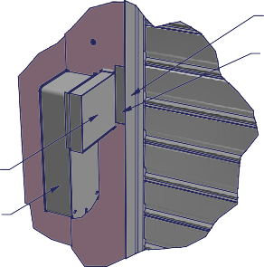
VIEW C

Interface

Actuator

Stone wool min 30kg/m³

Up to 60mm infill

Damper casing

Void between interface and damper casing filled with stone wool.

Vertical Damper Installation in a Plasterboard Wall with Pattress
Actionair SmokeShield PTC - [AA/F 10708] (Illustrated above)
Actionair FireShield - [AA/F 10709]

Installation Method
- Fit track (of partition) to the ceiling.
- Suspend the damper from the ceiling through the centre of the partition ceiling track using 10mm studding drop rods.
- Frame out the damper using tracks and studs lined with board. This is done with a lined track above the damper crossing between the nearest two full height studs, two vertical lined studs as close to the damper as possible (outside the cleats) from the top cross track to the floor and a lined cross track below the damper between the two vertical studs.
- Build the partition to the track and stud framework, between 50 mm - 60 mm to the damper.
- Insulate the wall with mineral/stone wool (if required).
- Seal the damper to the partition with intumescent sealant and add pattresses to both sides down to the damper spigot, seal to the damper spigot with

intumescent sealant.
- Finish the wall as standard practice.
- A minimum of 200 mm between fire dampers installed in separate ducts and 75 mm between fire damper and a construction element (wall/floor).

3

20220526 - LNNN00353 (5.1) Swegon reserves the right to alter specifications.

Actionair DWFX-C Installation Guide

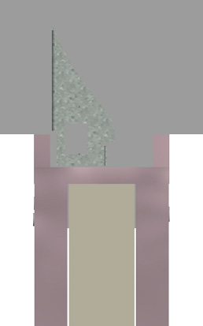
SECTION C-C
Stone wool 30kg/m³ 2-off 12.5mm (type 5) plasterboard both sides
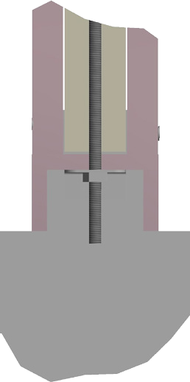

fixed with min Ø 4mm
drywall screws at least 50mm long
(at 150mm centers)

Low pressure intumescent mastic, applied all round
both sides.

min 100mm thick wall

M10 drop rods

M10 nuts
Low pressure intumescent mastic, applied all round both sides.

Damper casing

VIEW A

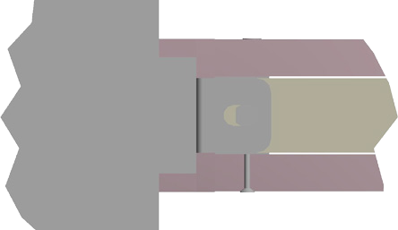


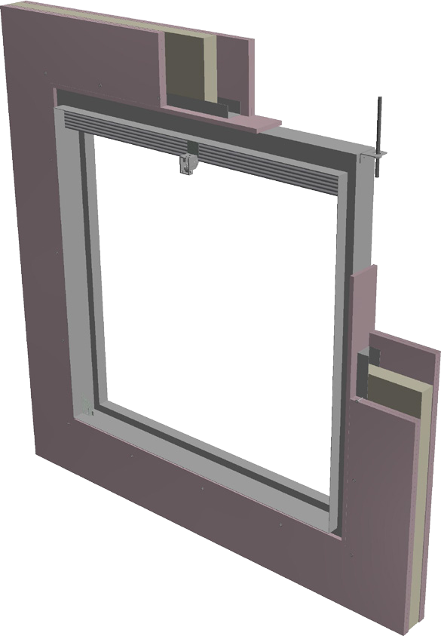
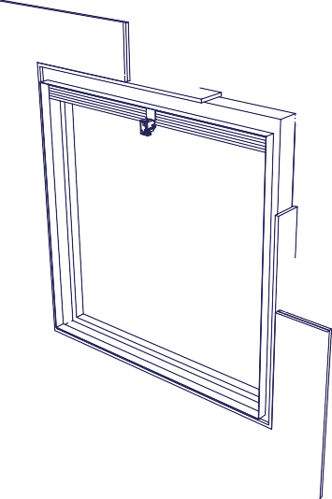
12.5mm plasterboard strips
B
A
C
C
around perimeter of damper casing.

50x25x2mm angle cleats welded to damper casing, both ends.

Stone wool 30kg/m³ min. 40mm thick
78
38

VIEW B
38

Vertical Damper Installation in a Plasterboard Wall without Pattress
Actionair FireShield - [AA/F 10723]

Installation Method
- Fit track (of partition) to the ceiling.
- Suspend the damper from the ceiling through the centre of the partition ceiling track using 10mm stud-ding drop rods.
- Frame out the damper using tracks and studs lined with board. This is done with a lined track above the damper crossing between the nearest two full height studs, two vertical lined studs as close to the damper as possible from the top cross track to the floor and a lined cross track below the damper between the two vertical studs.
- Build the partition to the track and stud framework, coming as close to the damper spigot as possible.
- Seal the damper spigot to the partition (all round, both sides) with low pressure intumescent sealant.
- A minimum of 200 mm between fire dampers installed in separate ducts and 75 mm between fire damper and a construction element (wall/floor).

- Finish the wall as standard practice.

4 Swegon reserves the right to alter specifications. 20220526 - LNNN00353 (5.1)

Actionair DWFX-C Installation Guide

SECTION C-C
VERTICAL BLADES;
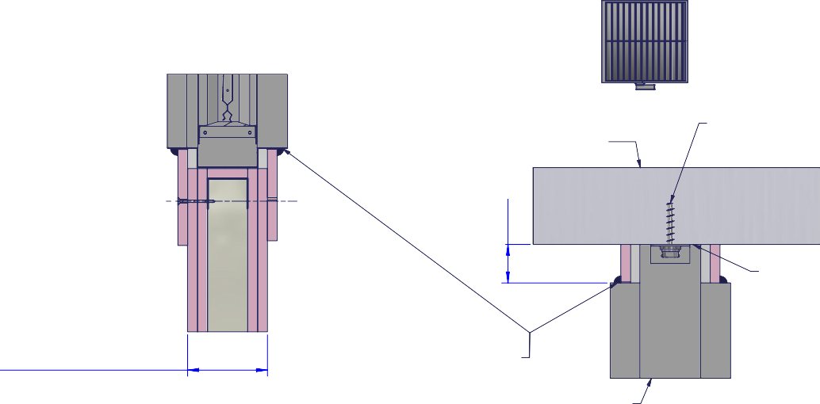
Damper can be installed with the blades in the vertical orientation with the actuator mounted at the bottom, refer to drawings for cleat locations; standard DWFX-C = AAF/0244DWFX-C actuator at bottom = AA-SS-2001

Concrete floor
50mm
Fire rated steel fixing
and washer M6 x 60mm. min.

min 100mm wall thickness

Width 5-10mm. of low pressure intumescent mastic, applied all round & both sides.

Damper
Diameter 5-10mm. of low pressure intumescent mastic, applied in a wavy line along top edge of damper.

VIEW A

Interface

Void between interface and damper casing filled with stone wool.

Actuator
Width 5-10mm. of low pressure intumescent mastic, applied on three edges & both sides.
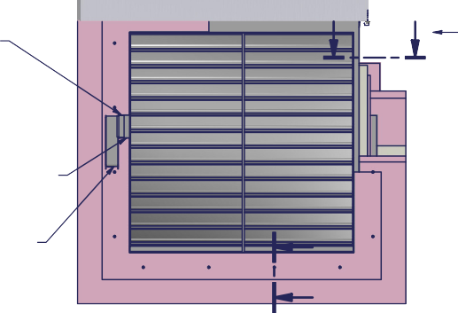
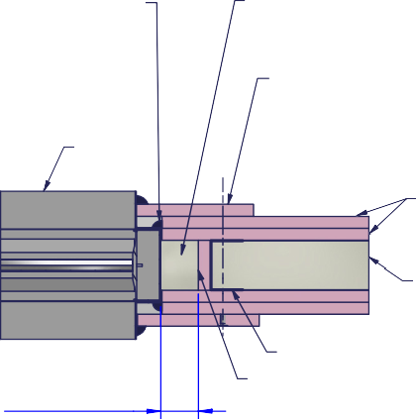
B
B
A
Damper

C
C Up to 60mm infill
Stone wool min 30kg/m³

12.5mm x 125mm gypsum fire board type F (EN520) on three sides, fixed with min
Ø 4mm drywall screws at least 60mm long (@300mm ctrs) into UDT52 stud channels.

2-off 12.5mm gypsum fire boards type F (EN520) both sides.

Stone wool min 30kg/m³
at least 40mm thick

UDT52 stud channel.
12.5mm gypsum fire boards type F (EN520)

SECTION B-B

Vertical Damper Installation in a Plasterboard Wall against a Floor Slab
Actionair SmokeShield PTC - [AA/F 10730] Actionair FireShield - [AA/F 11682]

Installation Method
- Apply a bead of low pressure intumescent mastic along top edge of damper as a gap filler and Install the damper against the floor slab and fasten using fire rated steel fixings and a washer.
- Frame out the damper using tracks and studs lined with board. This is done with two vertical lined studs as close to the damper as possible (outside the cleats) and a lined cross track below the damper between the two vertical studs and back fill with mineral/stone wool.
- Build the partition to the track and stud framework, coming as close to the damper as possible.
- Insulate the wall with mineral/stone wool.
- Seal the damper to the partition with intumescent sealant and add pattresses to both sides down to the damper spigot, seal to the damper spigot with
intumescent sealant. Fasten the pattresses with drywall screws at 300mm centres on the sides and bottom such that they will allow screws to pull into the stud

and track around the hole. Fix the top pattress into the track at the sides.
- Finish the wall as standard practice.
- A minimum of 200 mm between fire dampers installed in separate ducts.

5
20220526 - LNNN00353 (5.1) Swegon reserves the right to alter specifications.

Actionair SmokeShield – I/F (Installation Frame) Installation

5

Actionair I/F Installation Guide

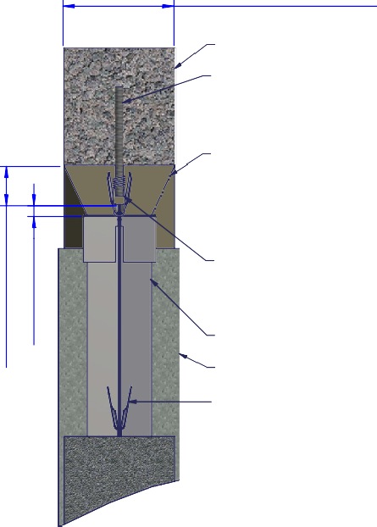
min 150mm wall thickness @ 500kg/m³ density

Lintel
Ø6.5mm (min)
steel anchors (top edge only)

4:1 sand : cement mix mortar or with a mortar appropriate for the expected fire resistance period. Fire refractory mortars can also be used.

ERTICAL BLADES
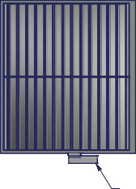
mper can be installed ith the blades in the rtical orientation with e actuator mounted at her the top or bottom.
V
Da w ve th eit
Actuator

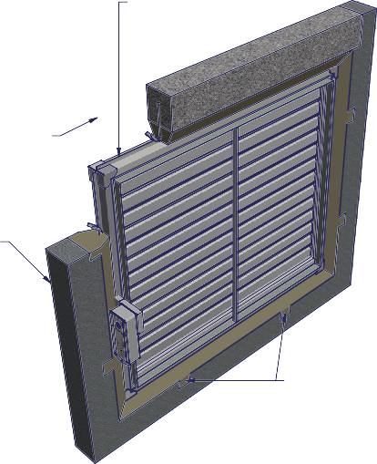
Ø1.5mm steel wire securing damper building ties, to stud anchors
Installation frame upstand flange
A
Building tie wall pockets
5mm - 75mm
All round from the installation frame upstand flange
to the aperture face.
21mm UPSTAND
(top edge only).


Installation frame Smoke shield damper
Building ties bent out into
wall pockets on sides & bottom

Aerated blockwork wall

Note:
VIEW A
(ALL ROUND DETAIL)

WALL POCKET DETAIL

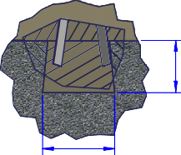
Dimension is flexible; bear in mind building tie wall pockets dimensions
APPROX
25mm - 75mm

APPROX
25mm - 100mm

Vertical Damper Installation in an I/F in a Masonry Wall
Actionair SmokeShield PTC - [AA/F10702] Actionair FireShield - [AA/F10703]

Installation Method
- Measure the positions of the building ties on the HEVAC frame.
Mark up the lintel at the top of the hole in the wall to give positions that match to the building ties. Drill into the lintel and fit stud anchors or similar steel fixings (min ø6.5mm x 60mm).
- Turn out the building ties on the damper and offer the damper into position, supporting from underneath with a block of wood or board, which will need to be removed when the mortar is in position.
- Using a steel wire, wrap this round the building ties and the stud anchors in the lintel at the top, to hold the damper in position (Note: This will also maintain the quality of the link between the damper, the infill mortar and the wall should a fire occur).
- Add mortar from both sides of the damper and infill to the HEVAC frame. Take care not to infill past the line on the interface shroud.
NOTE:
BUILDING TIE WALL POCKETS ON THE SIDES AND BOTTOM

20220526 - LNNN00352 (5.1) Swegon reserves the right to alter specifications. 3

Actionair I/F Installation Guide

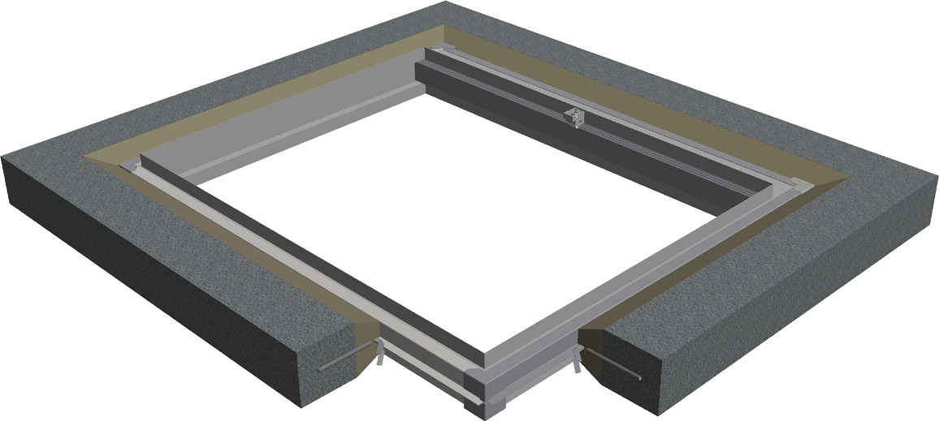
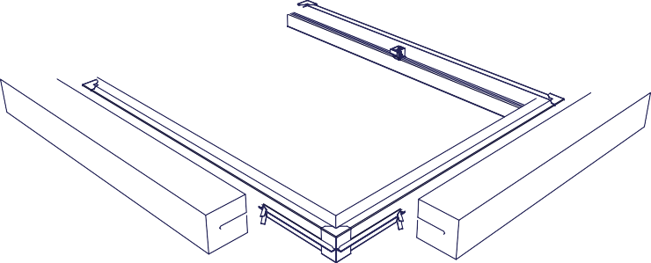
Installation frame
A upstand flange

Installation frame Fire damper
Building ties
bent outwards
4:1 sand and cement mix mortar or with a mortar appropriate for the expected fire resistance period. Fire refractory mortars can also be used.

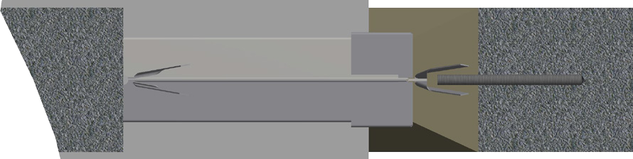
Aerated concrete slab (min 580Kg/m³)
75mm from top of slab to centre of damper
min depth 150mm

VIEW A
(ALL ROUND DETAIL)
21mm upstand 5mm - 75mm all round
from the installation frame upstand flange to the aperture face

minimum Ø6.5mm X 60mm fire rated anchors
Ø1.5mm steel wire securing damper building ties,
to stud anchors

Horizontal Damper Installation in an I/F in Slab
Actionair FireShield - [AA/F10701]

Installation Method
- Measure the positions of the building ties on the HEVAC frame.
- Mark up the inside edges of the hole in the slab to give positions that match to the building ties. Drill into the floor slab and fit stud anchors (min ø6.5mm x 60mm or similar) leaving them protruding into the opening.
- Turn out the building ties on the damper and offer the damper into position.
- Using steel wire (min ø1.5mm) wrap this round the building ties and the stud anchors to hold the damper in position (Note: This will also maintain the quality of the link between the damper, the infill mortar and the floor slab should a fire occur).
- Shutter beneath the damper (if required) and add mortar from the top of the slab and infill to the HEVAC frame. Take care not to infill past the line on the interface shroud if the motor is to be fitted above the slab.
- When the mortar is firm remove the shuttering (if applied) and infill with more mortar to the HEVAC frame from below the slab. Do not infill past the line on the interface shroud if the motor is to be fitted below the slab.

4 Swegon reserves the right to alter specifications. 20220526 - LNNN00352 (5.1)

Actionair SmokeShield – Dimensions

6

Actionair DWFX-F Installation Guide
DWFX-F Damper Dimensional Data

Actionair SmokeShield PTC
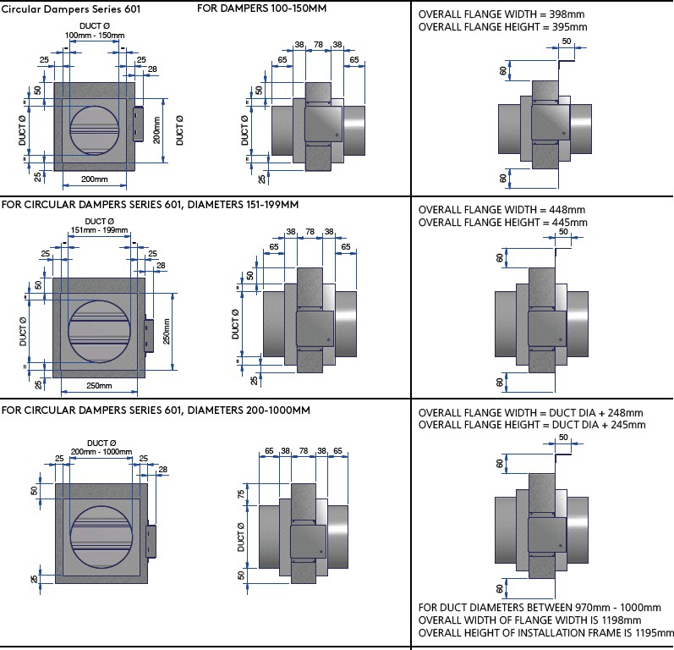

13
20220627 - LNNN00354 (4.2) Swegon reserves the right to alter specifications.

Actionair DWFX-F Installation Guide

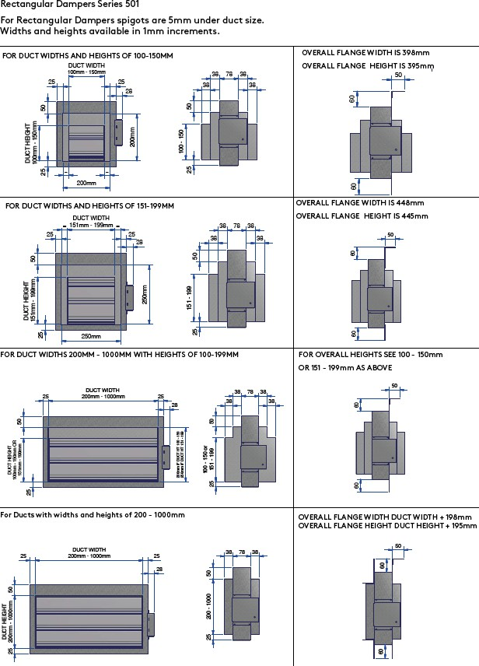

14 Swegon reserves the right to alter specifications. 20220627 - LNNN00354 (4.2)

Actionair DWFX-F Installation Guide

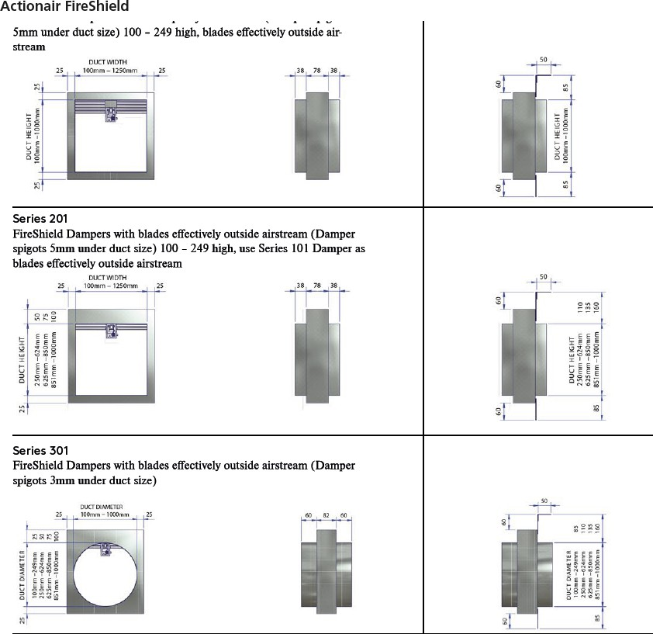
Actionair FireShield

15
20220627 - LNNN00354 (4.2) Swegon reserves the right to alter specifications.

Actionair DWFX-C Installation Guide
DWFX-C Damper Dimensional Data

SmokeShield PTC

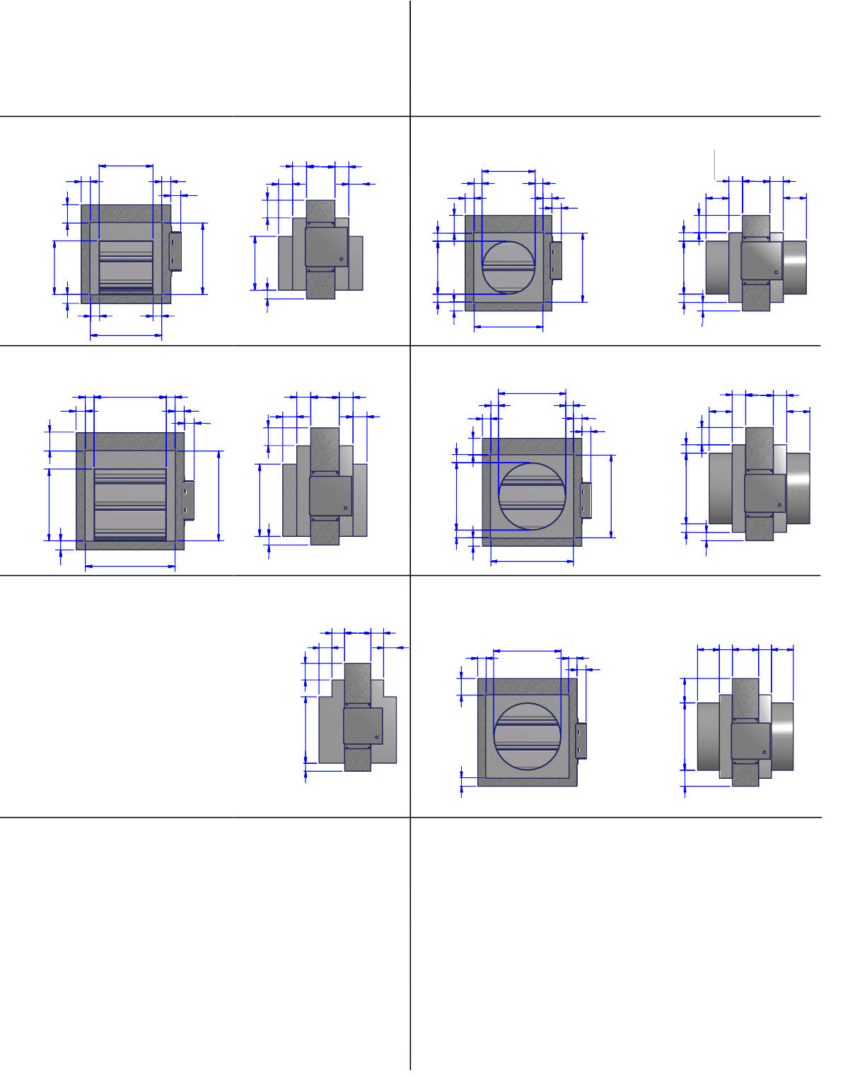
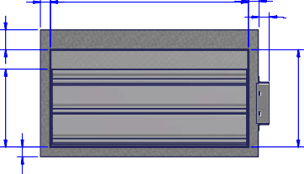
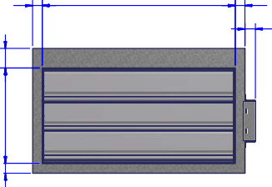
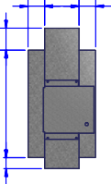
Base Dampers
Rectangular Dampers Series 501
For Rectangular Dampers spigots are 5mm under duct size. Widths and heights available in 1mm increments.

FOR DUCT WIDTHS AND HEIGHTS OF 100-150MM
DUCT WIDTH

Base Dampers
Circular Dampers Series 601
For Circular and Flat Oval Dampers spigots are 3mm under duct size. Diameters and flat oval diameters in 1mm increments.
Circular Dampers Series 601 FOR DAMPERS 100-150MM
DUCT Ø

100mm - 150mm
38 78 38
100mm - 150mm

25 25
28
50
38 38
= =
25 25
28
=
50
=
50
38 78 38
65 65
50

= =
DUCT HEIGHT
100mm - 150mm
25
200mm
100 - 150
DUCT Ø
=
200mm
DUCT Ø
DUCT Ø
=

200mm

200mm
25

FOR DUCT WIDTHS AND HEIGHTS OF 151-199MM
DUCT WIDTH

FOR CIRCULAR DAMPERS SERIES 601, DIAMETERS 151-199MM
25
25
DUCT Ø

= 151mm - 199mm =
25 25
28
50
50
38 78 38
38 38
50
151mm - 199mm
= =
25 25
28
=
50
DUCT Ø
=
38 78 38
65 65

250mm
DUCT HEIGHT
151mm - 199mm
25
250mm
151 - 199
25
=
DUCT Ø
250mm
=

FOR DUCT WIDTHS 200MM - 1000MM WITH HEIGHTS OF 100-199MM
250mm

FOR CIRCULAR DAMPERS SERIES 601, DIAMETERS 200-1000MM
25
25

DUCT WIDTH
25 200mm - 1000mm 25
28
50
50
38 78 38
38 38

DUCT Ø
200mm - 1000mm
25 25
28
DUCT HEIGHT
100mm - 150mm OR 151mm - 199mm
200mm IF DUCT HT 100 - 150
250mm IF DUCT HT 151 - 199
100 - 150 or
151 - 199
50
DUCT Ø
75

65 38 78 38 65

FOR DUCT WITH WIDTHS AND HEIGHTS OF 200 - 1000MM
Flat Oval Dampers Series 701
DUCT WIDTH 300mm - 1000mm 65 38 78 38 65
25
25
25
50

DUCT WIDTH
25 200mm - 1000mm 25
28
50 DUCT Ø 75
DUCT HEIGHT
50 200mm - 500mm 75
DUCT HEIGHT
25 200mm - 1000mm 50
25
200 - 1000
50
38 78 38


25
25
28

10 Swegon reserves the right to alter specifications. 20220526 - LNNN00353 (5.1)

Actionair DWFX-C Installation Guide

FireShield

Base Dampers
Series 101  FireShield Dampers with blades partly in airstream (Damper spigots  -  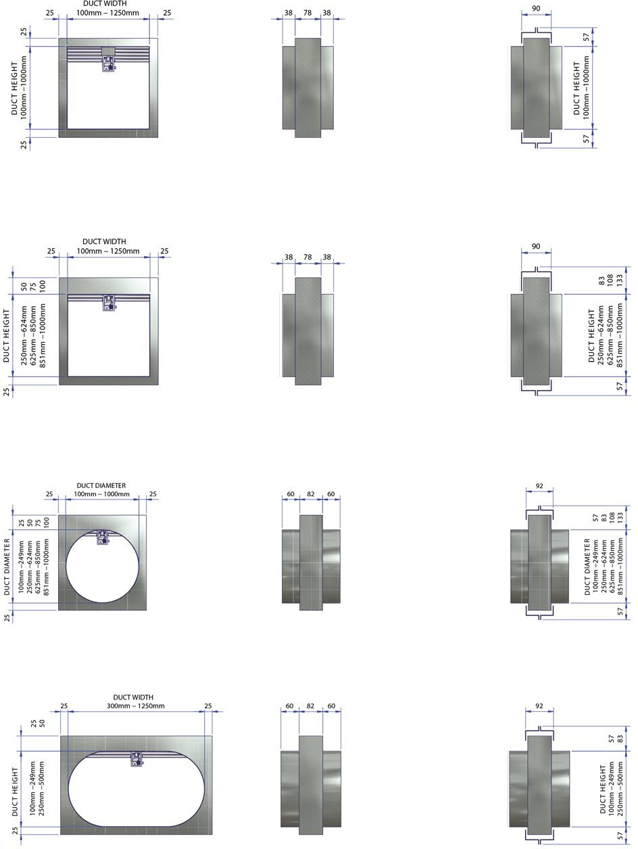  stream | OVERALL WIDTH OF INSTALLATION FRAME IS DUCT WIDTH + 114
Series 201  spigots 5mm under duct size) 100 - 249 high, use Series 101 Damper as | OVERALL WIDTH OF INSTALLATION FRAME IS DUCT WIDTH + 114
Series 301  spigots 3mm under duct size) | OVERALL WIDTH OF INSTALLATION FRAME IS DUCT WIDTH + 114
 | OVERALL WIDTH OF INSTALLATION FRAME IS DUCT WIDTH + 114

11
20220526 - LNNN00353 (5.1) Swegon reserves the right to alter specifications.

Actionair DWFX-C Installation Guide

Cleat dimensions SmokeShield PTC

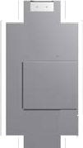
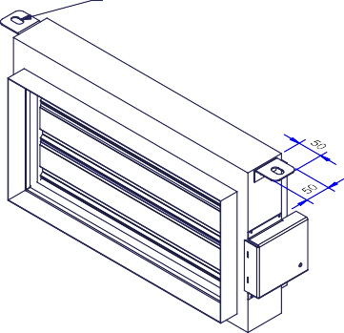
50 50 50
14mm x 24mm SLOT IN CLEATS

FireShield
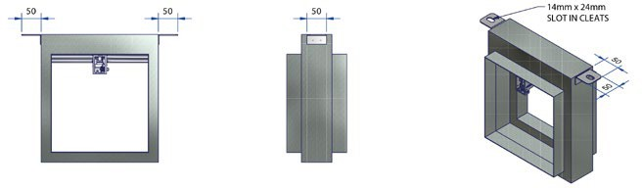

12 Swegon reserves the right to alter specifications. 20220526 - LNNN00353 (5.1)

I/F Dimensional Data

SmokeShield PTC

Base Dampers
Rectangular Dampers Series 501
For Rectangular Dampers spigots are 5mm under duct size. Widths and heights available in 1mm increments.

Actionair I/F Installation Guide

Dampers with I/F Installation Frames

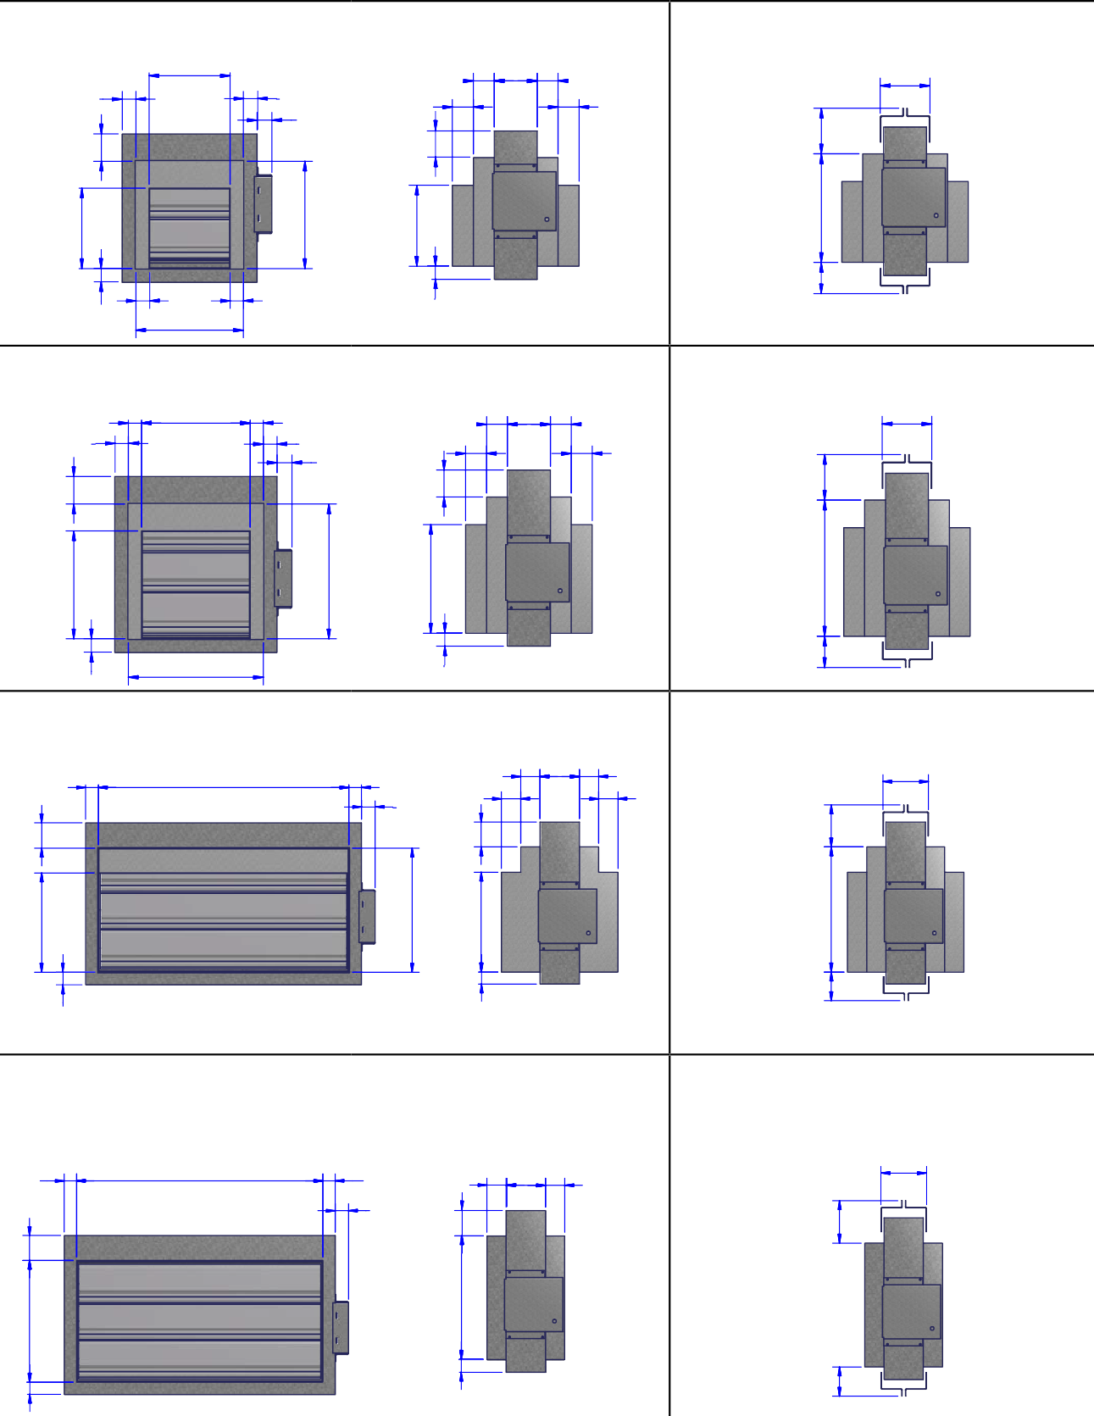
FOR DUCT WIDTHS AND HEIGHTS OF 100-150MM
DUCT WIDTH
100mm - 150mm

38 78 38
OVERALL WIDTH OF INSTALLTION FRAME IS 314mm OVERALL HEIGHT OF INSTALLATION FRAME IS 340mm
90

25 25
38
38
28
DUCT HEIGHT
100mm - 150mm
50
200mm
100 - 150
50
200
83

=
=
200mm

FOR DUCT WIDTHS AND HEIGHTS OF 151-199MM
25
25
57
DUCT WIDTH
= 151mm - 199mm =

38 78 38
OVERALL WIDTH OF INSTALLATION FRAME IS 364mm OVERALL HEIGHT OF INSTALLATION FRAME IS 390mm
90

25 25
38
38
28
50
250mm
50
250
83

250mm

FOR DUCT WIDTHS 200DMUCMT W- I1D0T0H0MM WITH HEIGHTS OF 100-199MM
DUCT HEIGHT
151mm - 199mm
25
151 - 199
25
57
FOR OVERALL HEIGHTS SEE 100 - 150mm OR 151 - 199mm AS ABOVE

DUCT WIDTH
25 200mm - 1000mm 25
28
DUCT HEIGHT
100mm - 150mm OR 151mm - 199mm
50
200mm IF DUCT HT 100 - 150
250mm IF DUCT HT 151 - 199
50
200 OR 250
38 78 38 90
38 38
83

FOR DUCT WITH WIDTHS AND HEIGHTS OF 200 - 1000MM
25
100 - 150 or
25 151 - 199
57

OVERALL WIDTH OF INSTALLATION FRAME DUCT WIDTH
+ 114mm - OVERALL HEIGHT OF INSTALLATION FRAME DUCT HEIGHT + 140mm

DUCT WIDTH
25 200mm - 1000mm 25
28
50
200 - 1000
50
83
90
38 78 38

20220526 - LNNN00352 (5.1) Swegon reserves the right to alter specifications. 9
DUCT HEIGHT
25 200mm - 1000mm
25
57

Actionair I/F Installation Guide

Base Dampers
57
200
83
57
250
83
Circular Dampers Series 601
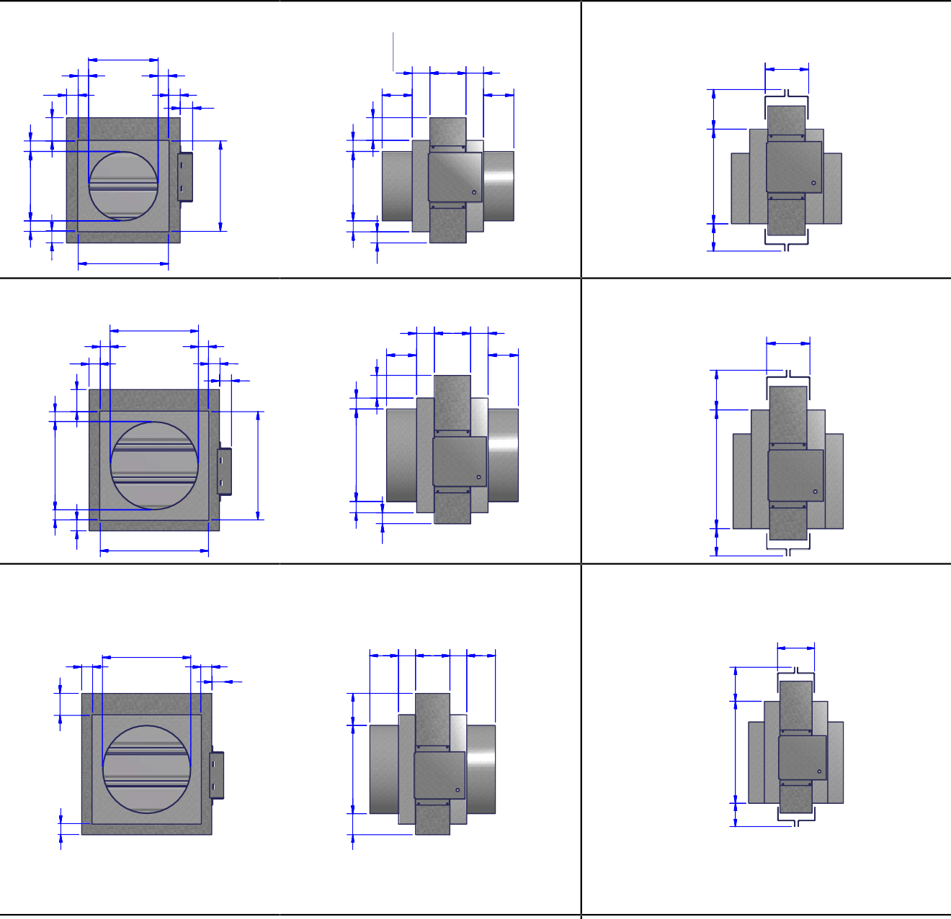
For Circular and Flat Oval Dampers spigots are 3mm under duct
Circular Dampers Series 601
DUCT Ø
100mm - 150mm
FOR DAMPERS 100-150MM
OVERALL WIDTH OF INSTALLTION FRAME IS 314mm OVERALL HEIGHT OF INSTALLATION FRAME IS 340mm
90
= =
38 78 38
25
25
65
65
28
FOR CIRCULAR DAMPERS SERIES 601, DIAMETERS 151-199MM
DUCT Ø
151mm - 199mm 38 78 38
=
=
OVERALL WIDTH OF INSTALLATION FRAME IS 364mm
OVERALL HEIGHT OF INSTALLATION FRAME IS 390mm
90
25
25
28
65
65
FOR CIRCULAR DAMPERS SERIES 601, DIAMETERS 200-1000MM
OVERALL WIDTH OF INSTALLATION FRAME = DUCT DIA + 166MM
OVERALL HEIGHT OF INSTALLATION FRAME = DUCT DIA +
DUCT Ø
200 mm
mm - 1000
65 38 78 38 65
190MM
90
25 25
28
FOR DUCT DIAMETERS BETWEEN 970mm - 1000mm
OVERALL WIDTH OF FLANGE WIDTH IS 1198mm OVERALL HEIGHT OF INSTALLATION FRAME IS 1195mm
250mm
200mm
DUCT Ø
=
=
25
50
DUCT Ø
=
=
25
50
200mm
DUCT Ø
250mm
DUCT Ø
DUCT Ø
=
=
=
=
50
50
25
25

10 Swegon reserves the right to alter specifications. 20220526 - LNNN00352 (5.1)
25
50
50
DUCT Ø
75
57
200 OR 250
83

Dampers with I/F Installation Frames

Actionair I/F Installation Guide

FireShield
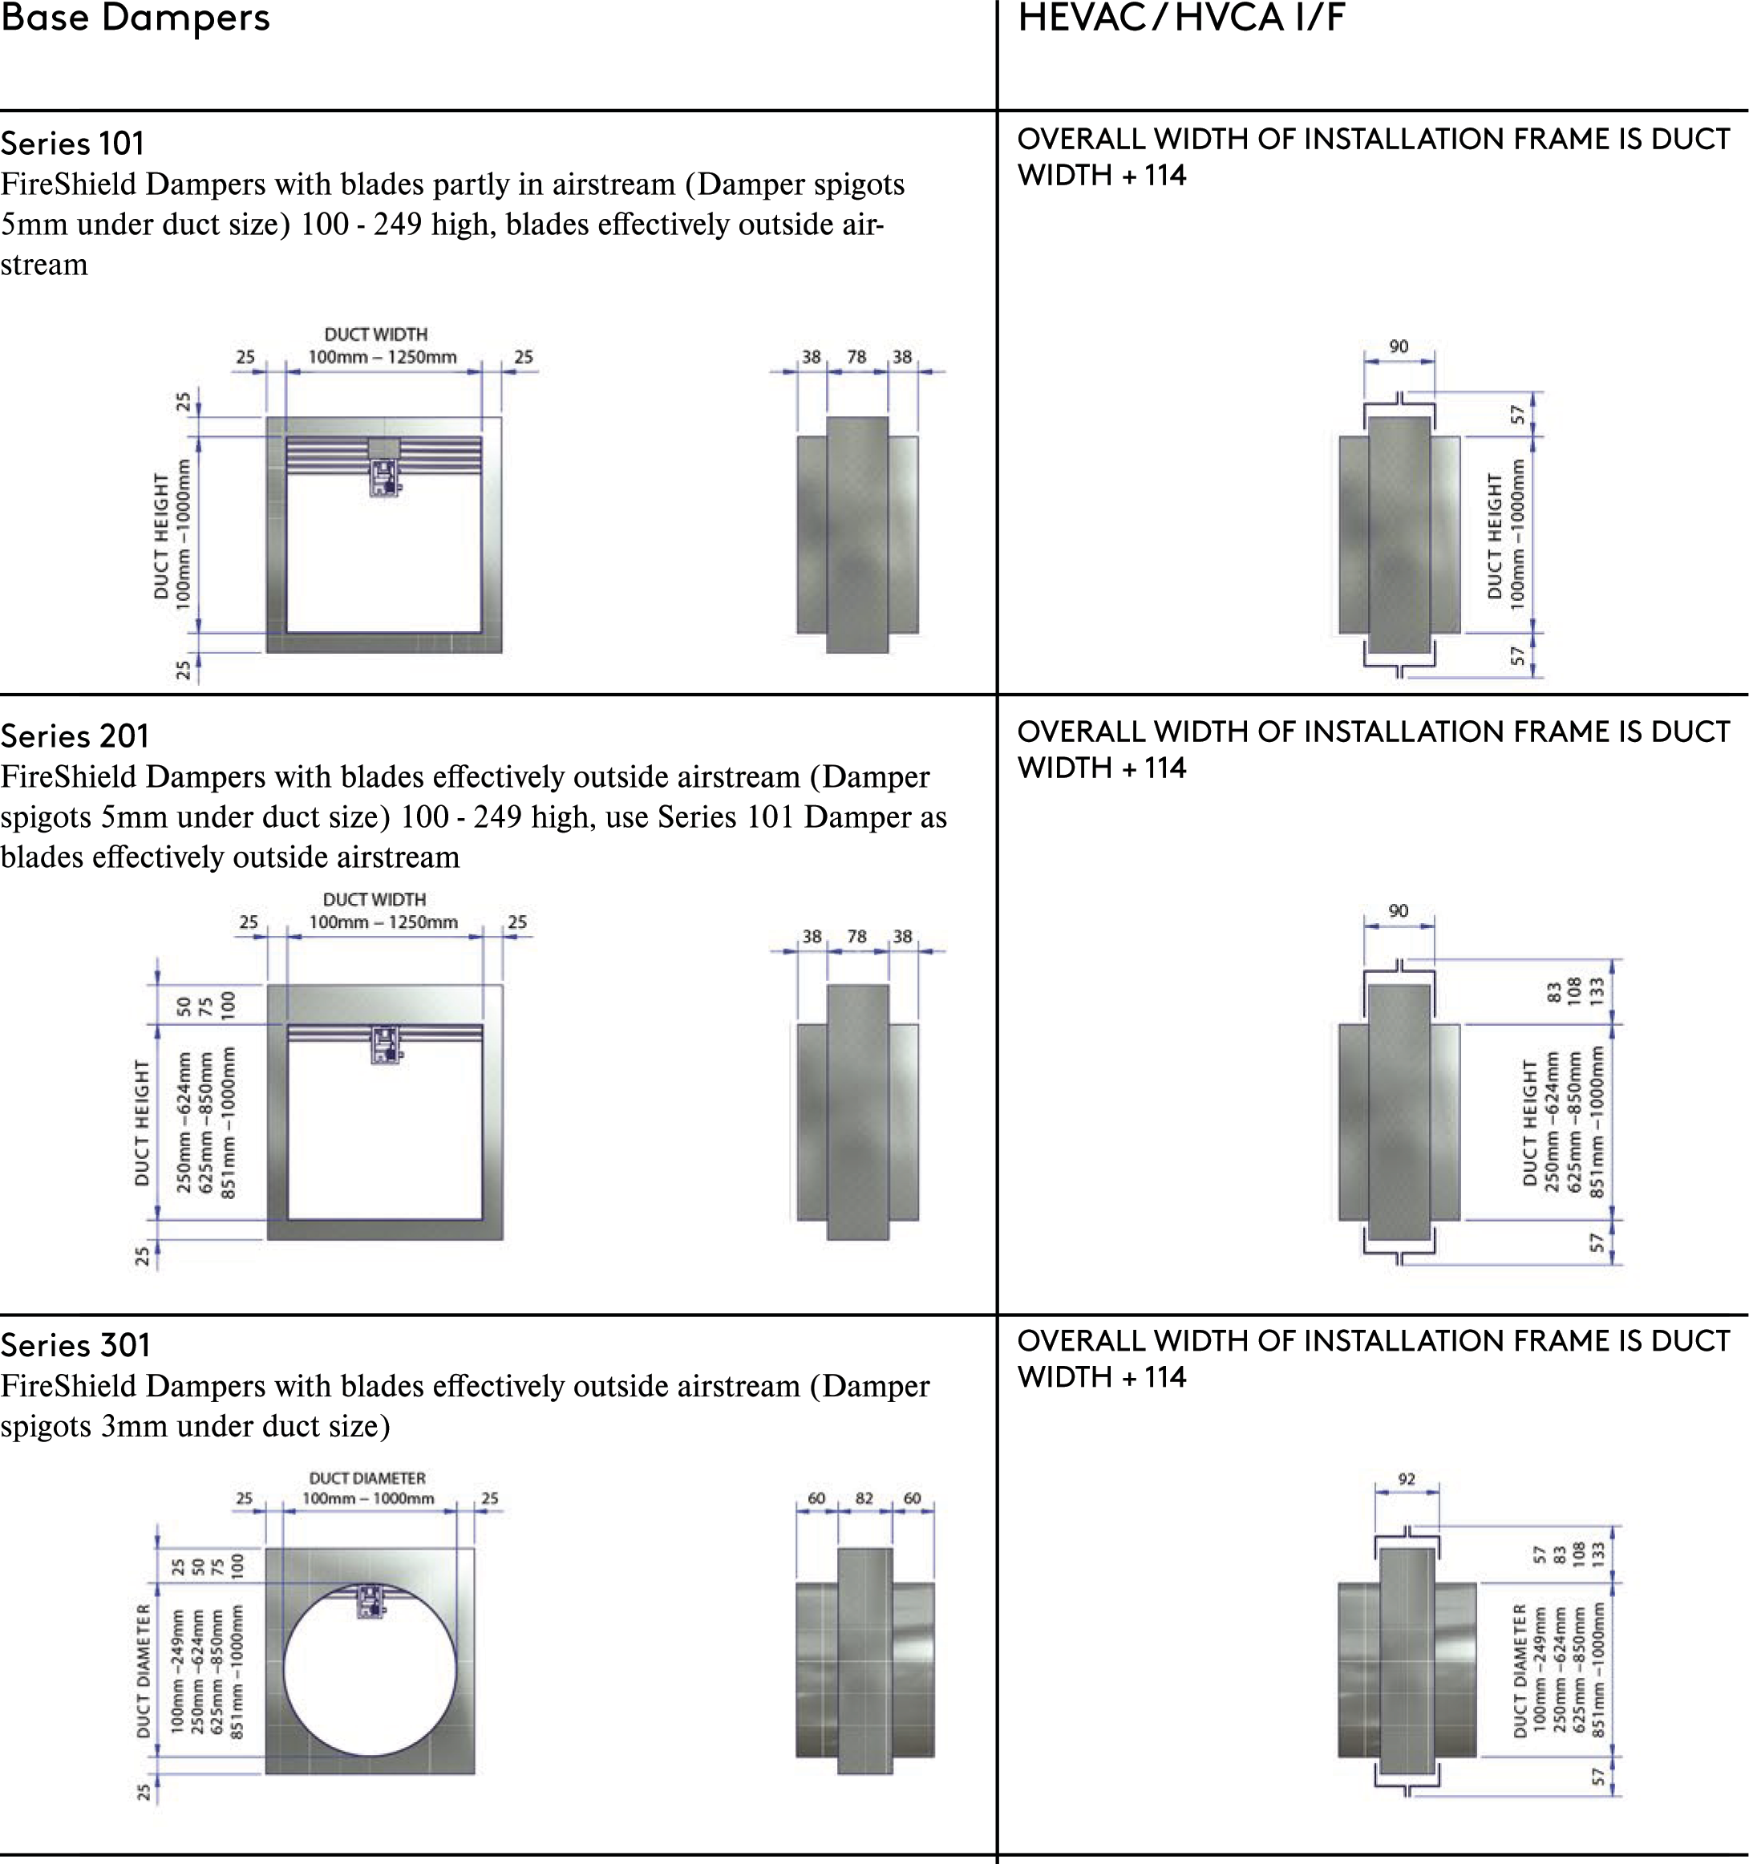

20220526 - LNNN00352 (5.1) Swegon reserves the right to alter specifications. 11

Actionair SmokeShield – Multiple Installation

7

Actionair DWFX-F Installation Guide - Multiple Assembly

Vertical Damper Installation in Standard Flexible Supporting Construction (Plasterboard Wall)
Actionair SmokeShield V2 - [AA/F13409] Please see Figure Drawings on next page

Installation Method
- Place the two top dampers (dampers with hanging cleats) together with the actuators to the outside, ensuring the inside edge side plates line up (Fig 1).
- Rivet the dampers together through the pre punched holes on the side plates with the provided 4mm rivets on both sides, ensuring that the rivet head is on the slot side (Fig 2).
- Repeat the process for the bottom two dampers.
- Lay the dampers down and position them so that the remaining plates line up (Fig 3).
- Rivet the dampers together on the available face
- Rotate the dampers over so that you flip them from the side to provide support to the damper ensure that the flange doesn’t get damaged in this process, do not use the hanging cleats for this (Fig 4).
- Rivet the remaining plates together, all holes should now have a rivet in, on both sides of the damper (Fig 5).
- Measure the overall damper casing size w x h, include the PTC Shroud (28mm) in the width but do not include any of the peripheral flange.
- Calculate the hole to cut size by adding two board thicknesses to the finished hole width and height.
- Mark out the hole on the partition and cut it out, cut- ting the top and bottom edges first to maintain stability.
- Frame out the hole with stud and track and cover this with board. Finish edges with joint filler (Fig 6).
- Drill clearance holes in the damper flange at 150mm centres and such that they will allow screws to pull into the stud and track around the hole.
- Install the damper and fix to the wall through the flange as shown in the drawing. Drop rods are to only have a nut and washer on the underside of the cleat, and must not be position such that they are applying a forces that will cause the damper to be levered away from the wall.

Vertical Damper Installation in Standard Rigid Supporting Construc-tion (Masonry Blocks)
Actionair SmokeShield PTC - [AA/F13410] Please see Figure Drawings on next page

Installation Method
- Place the two top dampers (dampers with hanging cleats) together with the actuators to the outside, ensuring the inside edge side plates line up (Fig 1).
- Rivet the dampers together through the pre punched holes on the side plates with the provided 4mm rivets on both sides, ensuring that the rivet head is on the slot side (Fig 2).
- Repeat the process for the bottom two dampers.
- Lay the dampers down and position them so that the remaining plates line up (Fig 3).
- Rivet the dampers together on the available face
- Rotate the dampers over so that you flip them from the side to provide support to the damper ensure that the flange doesn’t get damaged in this process, do not use the hanging cleats for this (Fig 4).
- Rivet the remaining plates together, all holes should now have a rivet in, on both sides of the damper (Fig 5).
- Measure the overall damper casing size w x h, include the PTC Shroud (28mm) in the width but do not include any of the peripheral flange.
- Using the holes sizer program check the opening in the wall matches the size of the damper
- Drill clearance holes in the damper flange at 150mm centres and such that they will allow screws to pull into the stud and track around the hole.
- Install the damper and fix to the wall through the flange as shown in the drawing. Drop rods are to only have a nut and washer on the underside of the cleat, and must not be position such that they are applying a forces that will cause the damper to be levered away from the wall.

20221102 - L00025 Swegon reserves the right to alter specifications. 3

Actionair DWFX-F Installation Guide - Multiple Assembly

Figure images

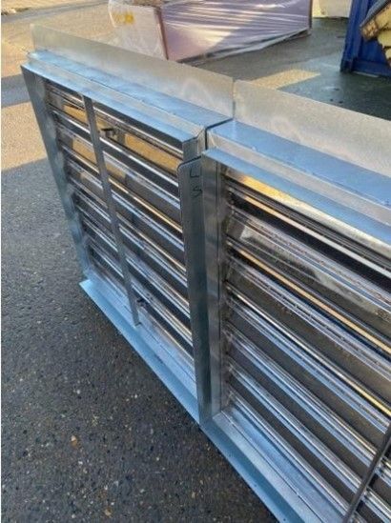
Fig 1

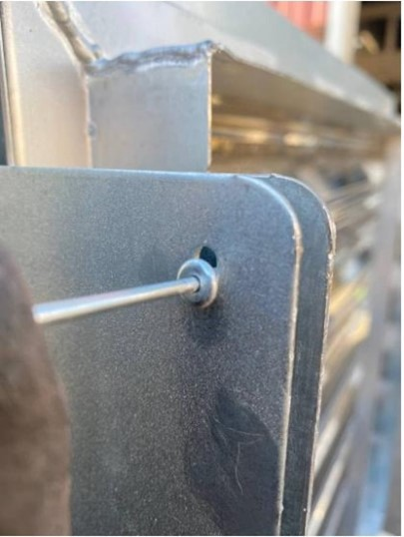
Fig 2

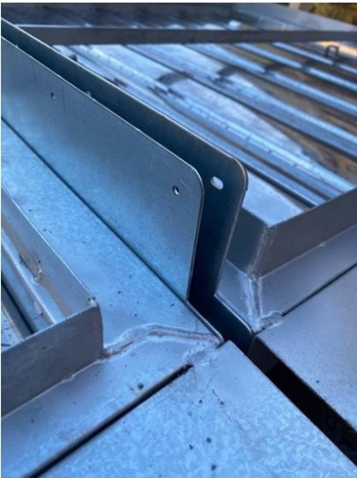
Fig 3

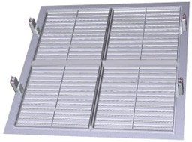

Fig 4

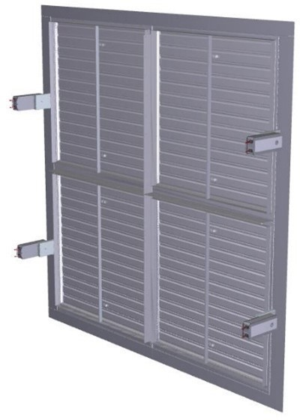
Fig 5

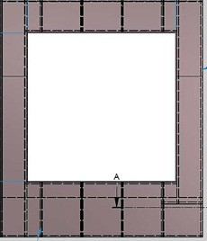
Fig 6

4 Swegon reserves the right to alter specifications. 20221102 - L00025

Actionair DWFX-F Installation Guide - Multiple Assembly
Dimensional Data
Rectangular Dampers Series 501
For Rectangular Dampers spigots are 5mm under duct size. Widths and heights available in 1mm increments.
2 x 1 Section Multiple Assembly
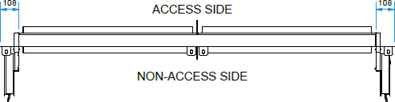
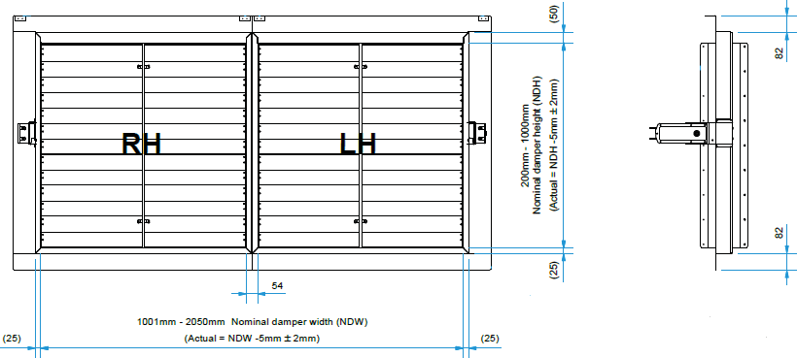

1 x 2 Section Multiple Assembly
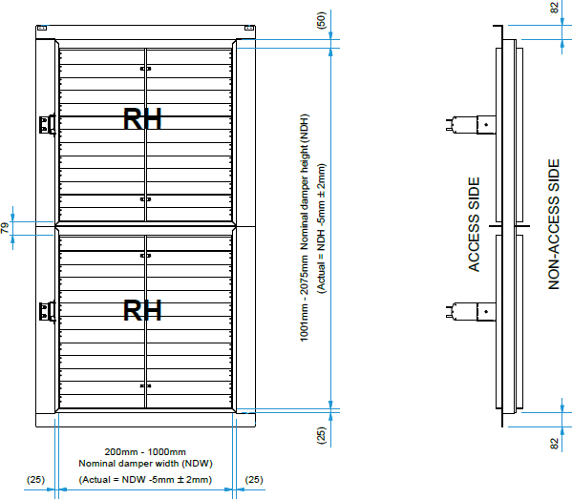
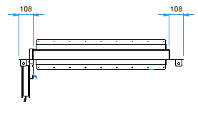

8 Swegon reserves the right to alter specifications. 20221102 - L00025

